\*The following document is a draft for PODv4.5. The manual will be based on the manual for PODv4 (located in the POD4.5 repository).

NEW Table Of Contents

List of FIGURES i

Foreword iv

1.0-INTRODUCTION

2.0-Description of PODv4

\*Same subsections as original PODv4 manual

3.0-New Features of PODv4

*3.1 New Features with Hit/Miss Data*

3.1.1 New Regression Techniques

3.1.2 New Confidence Interval Methods

3.1.3 New Sampling Methods

3.1.4 Quick tip box, warning box, and Informed Model Failure

*3.2 New Features with Signal Response*

3.2.1 Box-cox transformation

3.2.2 New Test of Assumptions

4.0-Implementation of PODv4

5.0-Software License Information

1.0 Introduction

The prime objective of this program was to provide improvements and new features to the PODv4 program with more modern mathematical methods and coding practices. The code providing the analysis was written in R which is connected through the user interface with R.NET. The reason for this is that there are many pre-existing libraries within R that allow complex statistical analysis. This appendix describes the user interface, and the standard outputs along with a detailed use of the program. This manual is more terse than traditional manuals since it provides dynamic documentation to the user as needed. The bulk of that information is included as part of the software itself. The primary focus of this manual is on using the software and critical high-level aspects of the software such as data importing and analysis exporting. Information such as that helps the user understand how best to integrate the software into their current workflow. In addition, this manual also describes the new features added to PODv4.5 that were not in PODv4 in order to aid users in utilizing said features.

The PODv4.5 software is based on the PODv4 user interface with completely new analysis code that was originally written in IronPython. The python backend in PODv4 contained outdated coding practices and no use of libraries at all. This made the analysis code very large and nearly impossible to maintain. The goal is to leverage PODv4’s user friendly interface and improve upon its analysis capabilities with new statistical methods and code that can more easily be maintained and modified.

PODv4.5 should look familiar to many users who use PODv4 since the overall user interface architecture is essentially identical with a few additional features and bug fixes. Overall, PODv4.5 is seen as more of a major update than a new program. The original backend algorithms are reimplemented in R . However, there are many new statistical methods and tests available to the user in order to provide more accurate results.

This user’s manual assumes familiarity with the objectives and analysis methods for fitting the cumulative lognormal and log odds models to â versus a and hit/miss (find/no find) forms of NDE reliability data. See References 1, 2, 5, and 6 for details of such analyses. Reference 2 contains a discussion of the specific analyses performed by POD v3.

Section 2 presents a description of the use of the program and the worksheets of a POD workbook for both the â versus a and hit/miss (find/no find) analyses. The descriptions emphasize the required input for a POD(a) analysis and the explanation of the output tables and graphs. The output sheets are standard worksheets of an Excel workbook. Knowledge of Excel is assumed. Section 3 provides an overview of new features provided for both Hit/Miss and ahat analyses. Section 4 presents the details of implementing the commands of the POD window. Section 5 provides a brief overview of the open-source licensing terms that PODv4.5 is under. The list of references are in Section 6

3.0-New Features of PODv4

*3.1 New Features with Hit/Miss Data*

3.1.1 New Regression Techniques

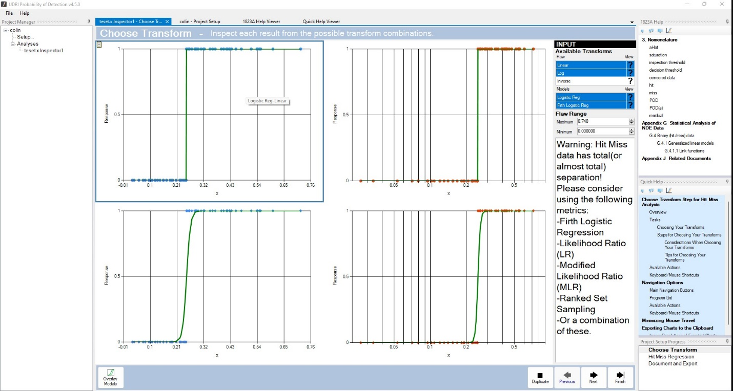

Figure 1 temp: Firth’s Bias Regression Convergence Example

One new feature added to PODv4.5 when performing Hit/Miss analysis is calculating the a90 curve using Firth’s bias-reduced regression Logistic Regression. Traditionally, the a90 curve was calculated using logistic regression with the maximum likelihood estimation. One potential issue with this technique is when the Hit/Miss data has near total (or in some cases) complete separation. In this context, separation refers to how much the 1s and 0s intersect in the data (\*\*\*\*ADD FIGURE FOR REFERENCE FROM SLIDES). When this occurs, the maximum likelihood ratio for logistic regression is unable to converge which fits 1s and 0s to the POD curve.

Firth’s bias-reduced logistic regression is useful in that it is capable of converging even if the dataset has total separation. In order to aid the user in which regression model they’d like to use (along with the transform type), both maximum likelihood logistic regression and firth logistic regression are provided. *Figure 1* demonstrates this in the transform panel. This example shows that the Hit/Miss data has complete separation. On the top two transforms, we can see that the traditional logistic regression failed to converge for both linear and log transforms. However, we can see that Firth logistic regression was able to successfully converge for both transforms.

It is worth noting that Firth’s bias-reduced regression is NOT always the optimal choice for producing the a90 curve. In some cases, when the maximum likelihood easily converges on the data, firth bias-reduced regression can produce results that are worse such as a larger a9095 value. PODv4.5 will sometimes provide advice to the user as to when firth logistic regression is a good choice for the input data.

3.1.2 New Confidence Interval Methods

Another helpful feature added to PODv4.5 is the additional confidence interval techniques implemented to help get a more accurate value for a9095 and a smoother confidence interval curve. Traditionally, the a9095 curve has been calculated using a standard Wald confidence interval at 95% confidence. However, standard Wald assumes the responses are normally distributed. In the case of Hit/Miss, the responses are only 0s and 1s. Thus, assuming normality can produce inaccurate values and smoothing issues with the confidence interval curve. The following section covers the following confidence interval methods:

* Modified Wald
* Likelihood Ratio
* Modified Likelihood Ratio

*Modified Wald* is a modification to the Standard Wald confidence interval in order to deal with potential linear interpolation issues between the available flaw sizes in the user’s dataset. If the data has large gaps in terms of flaw sizes, there may be smoothing issues in the a9095 confidence interval curve. Thus, Modified Wald generates 500 normally distributed crack after the logistic regression is created in order to fill in potential gaps in the flaw sizes and smooth out the confidence interval curve. This confidence interval is especially useful when dealing with small sample sizes and/or large gaps in flaw sizes because Modified Wald interpolates on 500 normally distributed crack sizes instead of *N flaw* sizes.

*Likelihood Ratio* confidence interval (LR) is a computationally intense optimization that fits a 95% confidence interval by maximizing the ratio of likelihoods. Standard Wald assumes that the sample size N is large enough such that the transformed responses are approximately normal. However, this is often not the case when it comes to Hit/Miss data. The LR confidence interval addresses this issue due to the fact that it does not assume normality of the transformed responses. While calculating the confidence interval takes time (~ 5 to 10 seconds), this the theoretically correct way to generate a POD a9095 curve when dealing with binomial (i.e. Hit/Miss) data. Parallelization has been applied to the R code in order to speed up the computation time slightly.

*Modified Likelihood Ratio* (MLR) is similar to the likelihood ratio confidence interval except that it applied higher order approximation (hoa) to the linear combination matrix prior to finding the confidence interval curve. The extra step makes it slightly slower than regular LR (~ 10 to 15 seconds).

\*\*\*\*\*TODO\*\*\*\*\*

3.1.3 New Sampling Methods

Traditionally, PODv4 executes a POD analysis using simple random sampling. This technique works sufficiently given the sample size is sufficient. However, in some cases, POD data sample sizes can be relatively small due to the high cost of producing POD studies. Thus, a small sample size of Hit/Miss data can fail to produce accurate results especially with the confidence interval curve.

In order to account for datasets with a smaller sample size, PODv4.5 introduces ranked set sampling. The idea of ranked set sampling is to gather data in such a way that it is more likely to span the full range of values in the population than the same number of observations acquired from simple random sampling. PODv4.5 leverages this technique by generating multiple ranked set sampling datasets based on the original input data (30 in total). A POD analysis is applied to all of the datasets, and the POD curve for a90 and a9095 is produced by taking the median of the results. Upon doing this, we can generate a90 and a9095 curves for data that has a relatively small sample size.

It is worth noting that ranked set sampling can be combined with either regression technique described in *section 3.1.1* and any confidence interval in *section 3.1.2*. However, it is worth noting that combing ranked set sampling with confidence interval techniques that are more computationally intense can take a long time (up to 20min in some cases). PODv4.5 will warn the user prior with an estimate ETA in the event the user chooses to do this.

3.1.4 Quick tip box, warning box, and Informed Model Failure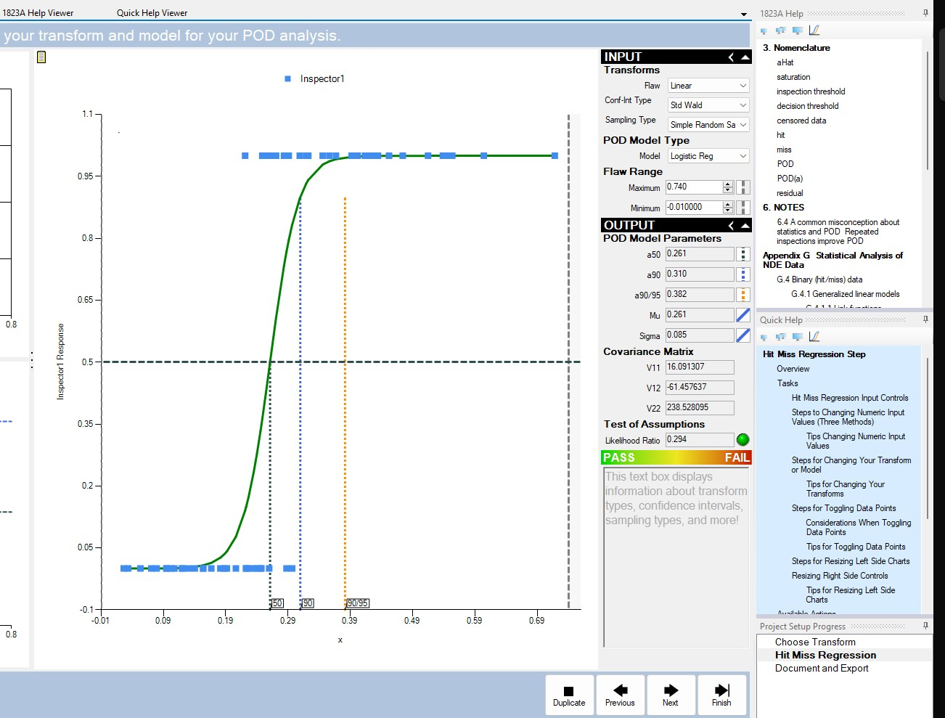

*

*Figure 3 temp:* *The quick help box displays the information on Modified Wald*

PODv4.5 includes a variety of quick help boxes, warning boxes, and information notifications in the event that the model fails in order to aid the user in generating an appropriate model for the data. The idea behind all these features is to help point the user in the right direction in a short timeframe.

Due to all the new features discussed in the previous *3.1* subsections, a quick help box was added to the main analysis panel in order to inform users what each feature does in the dropdown boxes. This is especially helpful for users who do not use PODv4.5 frequently. The quick help box is show in *Figure 2* below the test of assumption. If the mouse is not hovered over any dropdown, the text box will simple display the default message show.

In the event that the user hovers his or her mouse over a dropdown such as the modified Wald confidence interval (show in *Figure 3)*. The quick help box displays text dynamically giving the user a brief description of what the method is.

References (only new references)

https://www.hindawi.com/journals/isrn/2012/568385/